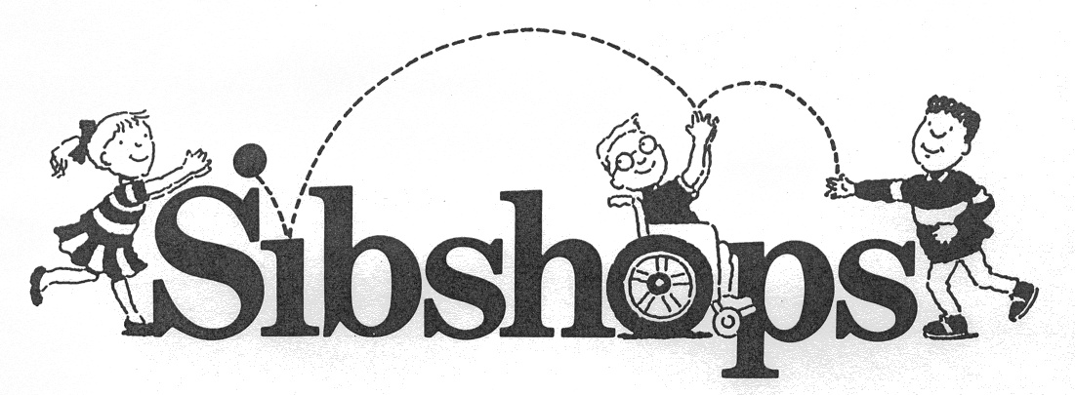
Registration Form

Baltimore 8-13 Harford County 6-12

Today’s Date:__________________________________

Child’s Name:_______________________________________________________________________________________

Date of birth:_____________________________ Age:___________ Gender:__________________________________

School:______________________________________________________________________________________________

Does this child receive any special services (ie- counseling, speech therapy, special education)?

__________________________________________________________________________________________________

Parent(s) name(s):__________________________________________________________________________________

E-mail address:____________________________________________________________________________________

Home address:_____________________________________________________________________________________

City:_____________________________________________________ Zip code:_________________________________

Contact number: ( )Home or ( )Cell phone_________________________________________________________

Name of brother/sister with special needs:______________________________________________________________

Date of birth:______________________________ Age:___________Gender:__________________________________

Nature of disability:__________________________________________________________________________________

School:______________________________________________________________________________________________

What type of related special education services (e.g. speech, occupational or physical therapy,

counseling, etc.) does this child receive?_________________________________________________________________

Other siblings:
Name: Date of birth: Age: Gender:

_____________________________________________________________________________________________________

_____________________________________________________________________________________________________

_____________________________________________________________________________________________________

What are your reasons for enrolling your child in the Sibshops program?

_____________________________________________________________________________________________________

Do you have concerns about enrolling your child in the Sibshops program?

_____________________________________________________________________________________________________

Do you have any particular topics that you would like addressed during the Sibshops?

_____________________________________________________________________________________________________

Please list 3 adults who will be responsible for picking up your child after each session.
Name: Date of birth: Relationship to child:

(1)__________________________________________________________________________________________________

(2)__________________________________________________________________________________________________

(3)__________________________________________________________________________________________________

Does your child have any allergies to food products?____________________________________________________

Does your child have any special dietary needs?________________________________________________________

How did you hear about Sibshops? ______________________________________________________________________

Please provide additional information that you feel will make this an enjoyable experience for your child.

_____________________________________________________________________________________________________

_____________________________________________________________________________________________________

I assume all risks and hazards of the conduct of the program and release from responsibility any person providing transportation to and from activities. In case of injury, I do hereby waive all claims or legal actions, financial, or otherwise against Mt. Washington Pediatric Hospital, Harford County Government Office of Disability Services, Mt. Zion United Methodist Church, The Arc Montgomery County, their elected officials and employees, the organizers, sponsors, supervisors, or any volunteer connected with the program. In absence of a signature, payment of fees and participation in the program shall constitute acceptance of the conditions set forth in the release.

________________________________________________________ __________________
Signature of parent or guardian Date

Email or mail completed forms to : sibshops@mwph.org

Mt. Washington Pediatric Hospital
Child Life and Therapeutic Recreation Department
Attention: SARAH BEALE/SIBSHOPS
1708 West Rogers Avenue
Baltimore, MD 21209-4596

